Angular JS - Concepts

Files Created
- index.html
- app.js
index.html
<!DOCTYPE html>
<html>
<head>
<title>AngularJS Hello World Example with Controller - Java4s.com</title>
</head>

<body ng-app="java4sApp">

<div ng-controller="HelloWorldController">
<font face="verdana" size="2px">Hello there, {{message}} !</font>
</div>

<script src="https://ajax.googleapis.com/ajax/libs/angularjs/1.3.2/angular.min.js"></script>
<script src="app.js"></script>
</body>
</html>

apps.js
var app = angular.module("java4sApp", []);
app.controller("HelloWorldController", function($scope) {
$scope.message = "Welcome to Java4s AngularJS Tutorials";
});

Sample application for example

DAO Class :
public void addTask(Task task) {
try {
PreparedStatement preparedStatement = connection
.prepareStatement("insert into task_list(task_name,task_description,task_priority,task_status,task_archived,task_start_time,task_end_time) values (?, ?, ?,?,?,?,?)");
System.out.println("Task:"+task.getTaskName());
preparedStatement.setString(1, task.getTaskName());
preparedStatement.setString(2, task.getTaskDescription());
preparedStatement.setString(3, task.getTaskPriority());
preparedStatement.setString(4, task.getTaskStatus());
preparedStatement.setInt(5,0);
Date dt = new Date();

SimpleDateFormat sdf =
new SimpleDateFormat("yyyy-MM-dd HH:mm:ss");

String currentTime = sdf.format(dt);
preparedStatement.setString(6,currentTime);
preparedStatement.setString(7,currentTime);
preparedStatement.executeUpdate();

} catch (SQLException e) {
e.printStackTrace();
}
}

Bean Class
public class Task {

private int task_id;
private String task_name;
private String task_description;
private String task_priority;
private String task_status;

public int getTaskId() {
return task_id;
}
public void setTaskId(int taskId) {
this.task_id = taskId;
}
@Override
public String toString() {
return "Task [task_id=" + task_id + ", task_name=" + task_name
+ ", task_description=" + task_description + ", task_priority="
+ task_priority +",task_status="+task_status+ "]";
}

Services – Add Task class
@RequestMapping(value="/tasks/insert/{taskName}/{taskDesc}/{taskPriority}/{taskStatus}",method = RequestMethod.POST,headers="Accept=application/json")
public List<Task> addTask(@PathVariable String taskName,@PathVariable String taskDesc,@PathVariable String taskPriority,@PathVariable String taskStatus) throws ParseException {
Task task = new Task();
task.setTaskName(taskName);
task.setTaskDescription(taskDesc);
task.setTaskPriority(taskPriority);
task.setTaskStatus(taskStatus);
taskmanagerservice.addTask(task);
return taskmanagerservice.getAllTasks();

}
}

DB Utility
public class DBUtility {
private static Connection connection = null;

public static Connection getConnection() {
if (connection != null)
return connection;
else {
try {
Properties prop = new Properties();
InputStream inputStream = DBUtility.class.getClassLoader().getResourceAsStream("/config.properties");
prop.load(inputStream);
String driver = prop.getProperty("driver");
String url = prop.getProperty("url");
String user = prop.getProperty("user");
String password = prop.getProperty("password");
Class.forName(driver);
connection = DriverManager.getConnection(url, user, password);
} catch (ClassNotFoundException e) {
e.printStackTrace();
} catch (SQLException e) {
e.printStackTrace();
} catch (FileNotFoundException e) {
e.printStackTrace();
} catch (IOException e) {
e.printStackTrace();
}
return connection;

Config.properties
driver=com.mysql.jdbc.Driver
url=jdbc:mysql://localhost:3307/taskmanager
user=root
password=root

app.js under webcontent / js folder (angular-animate – need to be manullay download)
- animate.css and style.css are downloaded as per requirements.
- taskManagerApp is the application workspace name
var taskManagerModule = angular.module('taskManagerApp', ['ngAnimate']);

taskManagerModule.controller('taskManagerController', function ($scope,$http) {

var urlBase="http://localhost:8080/TaskManagerApp";
$scope.toggle=true;
$scope.selection = [];
$scope.statuses=['ACTIVE','COMPLETED'];
$scope.priorities=['HIGH','LOW','MEDIUM'];
$http.defaults.headers.post["Content-Type"] = "application/x-www-form-urlencoded";

//get all tasks and display initially
$http.get(urlBase+'/tasks').
success(function(data) {
$scope.tasks = data;
for(var i=0;i<$scope.tasks.length;i++){
if($scope.tasks[i].taskStatus=='COMPLETED'){
$scope.selection.push($scope.tasks[i].taskId);
}
}
});

//add a new task
$scope.addTask = function addTask() {
if($scope.taskName=="" || $scope.taskDesc=="" || $scope.taskPriority == "" || $scope.taskStatus == ""){
alert("Insufficient Data! Please provide values for task name, description, priortiy and status");
}
else{
$http.post(urlBase + '/tasks/insert/' +$scope.taskName+'/'+$scope.taskDesc+'/'+$scope.taskPriority+'/'+$scope.taskStatus).
success(function(data) {
alert("Task added");
$scope.tasks = data;
$scope.taskName="";
$scope.taskDesc="";
$scope.taskPriority="";
$scope.taskStatus="";
$scope.toggle='!toggle';
});
}
};

- first most thing we need to download angular js script like below
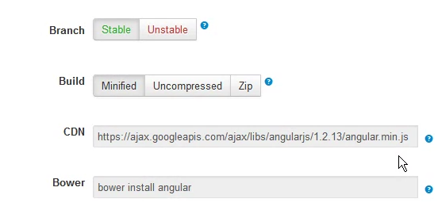

- Sample example
- ng-app is directive, it is must to have angular to work , if we need to use attribute inside html so we need to use data-ng-app.
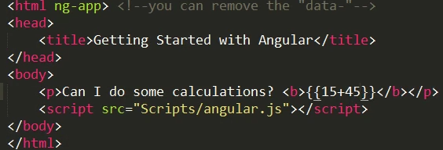
So in the double bracelet evaluation is happened.
- Since angular JS is a MVC pattern so we are modifiying the code like below
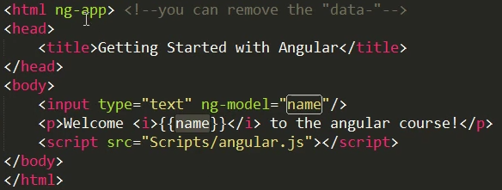
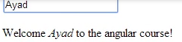

Repeat directive and filtering concepts in Angular JS
ng-int ( Initial an array)
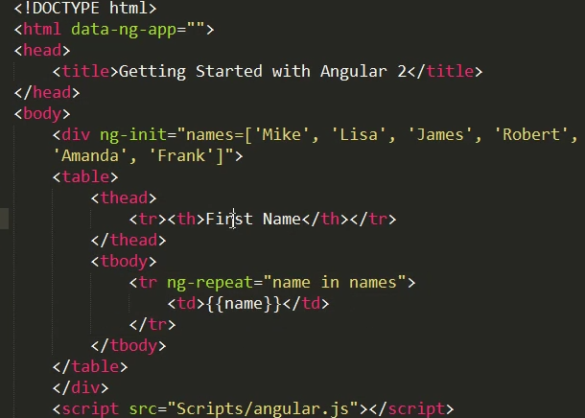
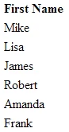

Filtering concepts in angularJS
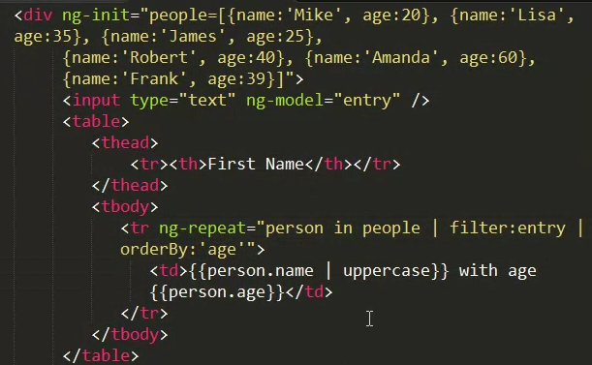

Use filter for searching the value, and you will see the below output screen
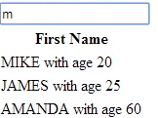

- Angular JS Controller concepts

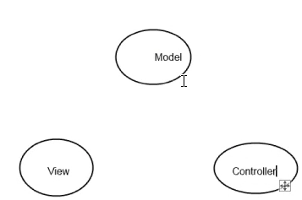

$scope as a service in angular JS, and also use directive in VIEW
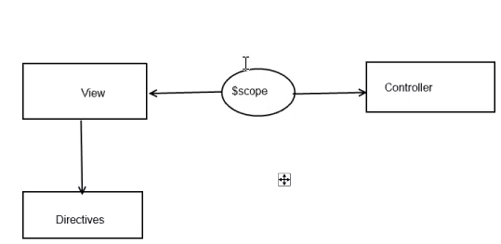

Module is important in the controller concepts in the angular JS.
So we need to create a separate .js file with the concepts like below.
Creating a module like below
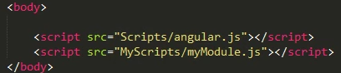
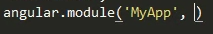 , module can depend on other module or service , if we are depending on anyother so we are making like below

So this need to refer in our html file like below, referring the module like below
Create controller and function like below
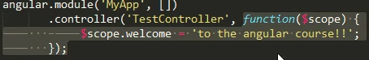
In HTML we have code like below
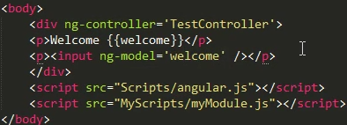
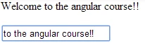

- Custom filtering concepts in Angular JS
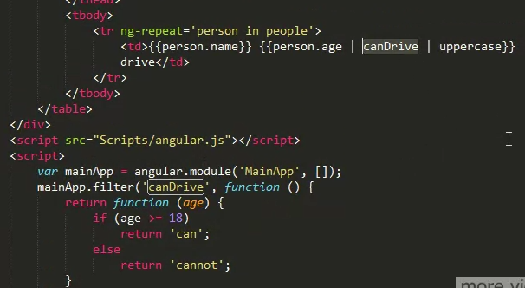

Ng-class concepts
